The ‘Development Gap’ has been identified as an area for improvement following the mock exams.
The information below has been taken from GCSE bitesize.
“The development gap is the difference in levels of development between the richest and poorest countries in the world. Many believe that the gap between the high-income countries (HICs) and low-income countries (LICs) is getting wider. Reducing the development gap would lead to an increase in the quality of life for millions of people around the world.”

Methods of reducing the development gap
Investment | Large companies can locate part of their business in other countries. This helps a country to develop as the companies build factories, lay roads and install internet cables.
Aid | Aid is when one or more countries give money to other countries. The money has to be spent on things that will benefit the population.
Using intermediate technology | Intermediate technology is using equipment and techniques that are suitable for their country of use. Many poorer countries do not have the skills to maintain expensive equipment. Small-scale, basic solutions are usually more appropriate.
Fairtrade | Fairtrade is paying producers a reasonable price for the goods that they produce. Many farmers in LICs are paid very low wages. This means that they cannot escape poverty. Fairtrade gives farmers a better chance in life.
Debt relief | Many LICs owe money to other countries. Often the repayments and interest are so expensive that indebted countries have no money left to spend on development projects. Debt relief is when debts are either reorganised to make them more manageable, or reduced.
Microfinance loans | Microfinance loans are when money is lent to LICs to help them to develop. These are often small loans with reasonable interest rates. They are available to people and businesses who may normally struggle to get credit.

Measures of development
Development in countries can be measured in several different ways. Some are economic measures, and others are social measures.
Human Development Index (HDI)
Development is measured using the Human Development Index (HDI)). HDI is calculated by the United Nations. It measures average life expectancy, level of education and income for each country in the world. Each country is given a score between 0 and 1 - the closer a country gets to 1, the more developed it is.
Other measures of development
HDI is the best measure of development as it takes into account both economic and social factors. However there are many other measures of development that can be used. Some of them are:
Measure of development | Description
Access to safe water | The percentage of people who have access to safe, clean water.
Birth rate | The number of live births per 1,000 people. Birth rates are often high in a less developed country.
Death rate | The number of deaths per 1,000 people. High death rates can indicate a less developed country.
GNI per capita | Gross national income per person. The value of a country's income, divided by the number of people in that country.
Infant mortality rate | The number of babies who don't survive to the age of 1 per 1,000 live births.
Life expectancy | The average age that a person may live to.
Literacy rate | The percentage of adults who can read and write.
People per doctor | A ratio to show the number of people per doctor. A lower ratio can indicate a richer country.

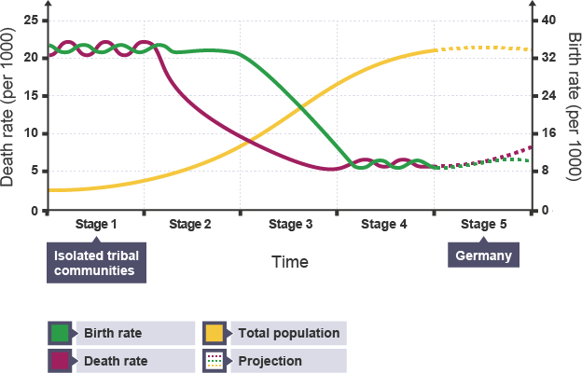
The Demographic Transition Model and development
The Demographic Transition Model (DTM) shows population changes over time. There are five stages in the DTM and these stages can be linked to levels of development.

Factors influencing global development
Levels of development are determined by several factors:
- Physical factors – some areas have a hostile or difficult landscape. This can make development more difficult. Examples of this are very hot climates or arid climates (with a lack of water) which make it difficult to grow sufficient food.
- Economic factors – some countries have very high levels of debt. This means that they have to pay a lot of money in interest and repayments and there is very little left over for development projects.
- Environmental factors – some places experience environmental issues, which can prevent them from developing. Examples might be extreme flooding or desertification.
- Social factors – some parts of the world have issues that are caused by people. These include low levels of education, poor water quality or a lack of doctors.
- Political factors – some countries are at war or the government may be corrupt. Therefore money does not reach the people who need it most and spending on areas such as education and infrastructure may be insufficient.
- Natural resources – some countries have an abundance of raw materials such as oil or precious minerals. These can be sold and the money invested into developing the country

Complete the questions below using the information above, your prior knowledge, GCSE bitesize and GCSEPod to help you.
- What is meant by the term the development gap?
- Give examples of countries or region that are more economically developed than others
- What is meant by the term quality of life?
- Define the term development
- Define the following terms and explain how each of them can be used to measure development:
  - Birth rate
  - GNI per capita
  - Death rate
  - Infant mortality rate
  - Life expectancy
  - People per doctor
  - Literacy rate
  - Access to safe water
  - HDI
- Identify which of the measures above are economic (to do with money) or social (to do with people)
- Explain the negatives of the different measures above (a-i)
- Suggest problems with use one single measure of development such as GNI, rather than a combined measure like HDI
- What is the purpose of the demographic transition model (DTM)?
- Describe what happens to birth and death rates in each of the stages of the DTM
- At what stage of the DTM would you expect to find more developed, high income countries?
- Describe the link between levels of development and stages of the DTM
- Explain why some countries are more developed whilst others remain less developed economically
- Name and explain how physical/natural factors can affect the development of a country
- Name and explain how historical factors can affect the development of a country
- Name and explain how economic factors can affect the development of a country
- Explain the how uneven development can cause migration. Can you think of an example?
- Explain how uneven development can cause differences in wealth and health
- Name five strategies used to reduce the development gap
- Explain how the following can reduce the development gap:
  - Tourism
  - Aid
  - Fair trade
  - Debt relief
  - Intermediate technology
  - Microfinance loans
  - Industrial development

